Issue Report
Issue : Gflip 7 – Missing Receiver
Solution request : Need visual inspection after assembly component
Requestor : Fui Ling – TCL
Date : 1 Desember 2025

Model Gflip
Terdapat 3 model Gflip:
- Gflip 5
- Gflip 6
- Gflip 7

Requirement Visual inspection

Gflip 5
Current Process – Part yang dipasang dan perlu visual check oleh operator:
- Vibrator
  - Pemeriksaan: Missing component
- Rubber (Merah)
  - Pemeriksaan: Missing component, warna rubber, orientasi/reverse
- Receiver (Orientasi ke bawah sesuai panah)
  - Pemeriksaan: Missing component, orientasi receiver
- Antenna
  - Pemeriksaan: Missing component, komponen terangkat
- Magnet
  - Pemeriksaan: Missing component

Gflip 6
Current Process – Part yang dipasang dan perlu visual check oleh operator:
- Vibrator
  - Pemeriksaan: Missing component
- Receiver (Orientasi ke atas sesuai panah)
  - Pemeriksaan: Missing component, orientasi receiver
- Antenna
  - Pemeriksaan: Missing component, komponen terangkat
- Magnet
  - Pemeriksaan: Missing component
- Dusket
  - Pemeriksaan: Missing component

Gflip 7
Current Process – Part yang dipasang dan perlu visual check oleh operator:
- Vibrator
  - Pemeriksaan: Missing component
- Receiver (Orientasi ke bawah sesuai panah)
  - Pemeriksaan: Missing component, orientasi receiver
- Rubber (Black Color)
  - Pemeriksaan: Missing component, warna rubber, orientasi/reverse
- Magnet
  - Pemeriksaan: Missing component
- Dusket
  - Pemeriksaan: Missing component
- Antenna
  - Pemeriksaan: Missing component, komponen terangkat

Environment (request to PID team / made by Engineer team)
- Box Cabinet
Sample : 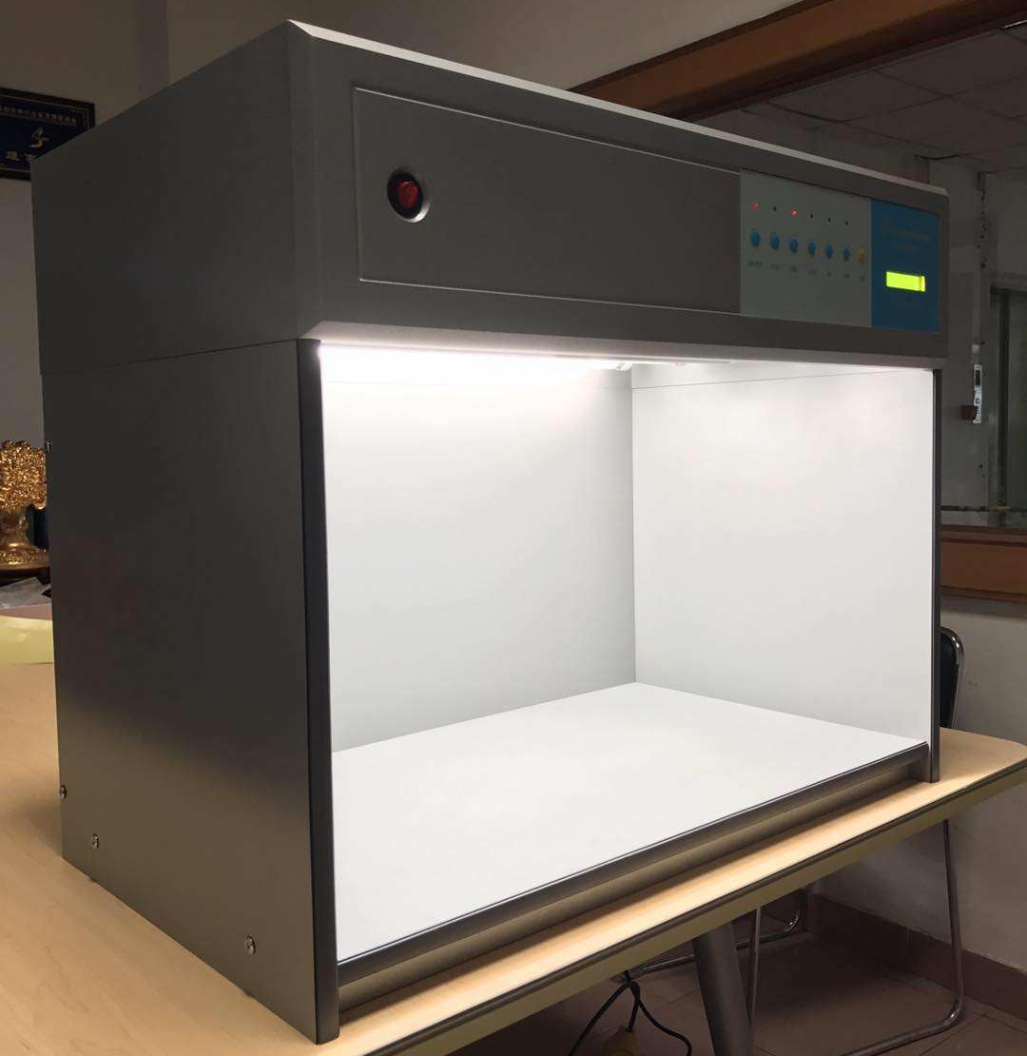
    - Warna : Hitam
    - Bahan : akrilik
  - Ukuran: Persegi panjang (P x L x T – waiting research)
  - Sensor untuk deteksi unit (trigger start inspection)
  - Relay control untuk On/Off lighting
- Lighting
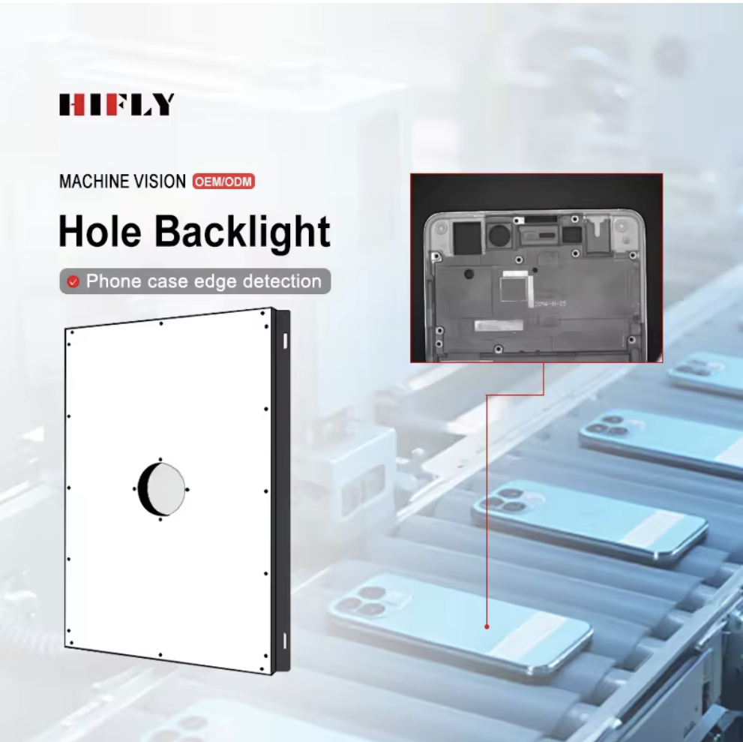
  - Qty: 1 Pcs
  - Bentuk: Square
  - Ukuran: (P x L – 400x200mm)
- Alarm / Speaker
  - Qty: 1 Pcs
- Mini PC / CPU
  - Qty: 1 Pcs
  - Minimal: Intel Core i7 (Gen 12)
  - RAM: Min. 8 GB DDR4
  - Storage: SSD 500 GB
  - OS: Windows 10
- Monitor
  - Qty: 1 Pcs
- Camera Hikrobot
  - Qty: 1 Pcs
  - Serial number: MV- CS200 -10UC
- Lens Hikrobot
  - Qty: 1 Pcs
  - Serial number: MVL-MF1228M-8MP

Total Investment (1 Unit inspection):
No. | Item | Detail | Qty | Unit Price | Total Price
1 | Box Cabinet |  | 1 Pcs | $500 | $500
2 | Lighting |  | 1 Pcs | $200 | $200
3 | Alarm |  | 1 Pcs | $60 | $60
4 | Mini PC / CPU |  | 1 Pcs | $500 | $500
5 | Monitor |  | 1 Pcs | $80 | $80
6 | Camera Hikrobot |  | 1 Pcs | $340 | $340
7 | Lens Hikrobot |  | 1 Pcs | $56 | $56
Total |  |  |  |  | $1736

